Page system Technical Reference

Page system can be considered as a Page Model (PM) and a set of formats to describe this model such as Page-Tab, PageML and Page-JSON.

Page-Model

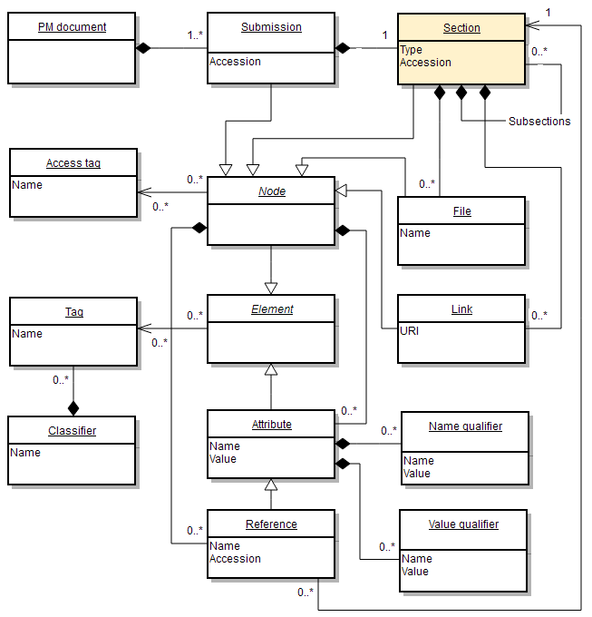

Page document

PD is a single piece of data containing one or more submissions

|  |  |
| --- | --- |
| Submission |  |
| … |  |
|  |  |
| Submission |  |
| … |  |

Submission

A submission defines a single unit of information in a database. A submission section starts with a **Submission** keyword. The next columns can be used to assign accession number, access tags and classification tags respectively.

|  |  |  |  |
| --- | --- | --- | --- |
| Submission | [acc no] | [acc tag list] | [cls tag list] |
|  |  |  |  |
|  |  |  |  |

Accession number

Accession number (or just accession) is used to identify submissions and sections. There are two kinds of accessions – local and global. Local accessions are used for referencing within the current submission and can be reused in the other submissions. Global accessions should be unique across the whole database and can be used for external references. Within the current submission global accessions can be used the same way as local ones. An accession is a string of ACSCII letters and digits. To show that some accession is global the prefixing exclamation mark should be used.

AAB678P – local accession

!XPC123 – global accession ‘XPC123’

There is a special syntax to enables accession to be generated by the system: !{Pfx,Sfx} where Pfx is a set of symbols not ending with a digit. Pfx is an optional set of symbols not starting with a digit.

!{A,B} – will be replaced with A234B

!{X} – X749

!{P8} – not allowed

All generated accessions are global.

Unlike section’s accession submission’s accession is always global. The exclamation mark can be omitted in this case.

If it is necessary to refer to a section with a generated accession the special form with temporary accession can be used: !tmpaccno{Pfx,Sfx}

!T1{EBI} - EBI8935 but T1 will be a local accession before new accession is generated.

Access tags

Access tags are alphanumeric tokens that are used to control access to submissions and its parts. Access tags should be defined within the system prior to a submission process. More than one tag can be assigned at once. A comma separated list is used for this purpose. E.g. Public,EBI

Classification tags

Classification tags should be represented in the form <classifier>:<tag> e.g. Color:Red. All referred classifiers and tags should be defined within the system prior to a submission process. More than one tag can be assigned at once. A comma separated list is used for this purpose. E.g. Render:Bold,Color:Blue,Priority:High

Attributes

An attribute is a pair of two string tokens: name and value. Classification tags can be assigned to an attribute.

References

A reference is a special form of an attribute. A value of the reference should be valid section’s accession defined (may be temporary) within the current submission.